Distributed System
HW #3

- This exercise uses EchoServer1 and EchoClient1, which use connectionless datagram sockets for the Echo service.

Compile Echo*1.java (“javac Echo*1.java”). Then:
  - Run the programs by starting the server (don’t forget to specify a port number as a command-line argument) first, then the client. Conduct a session and observe the diagnostic messages displayed on both sides. Describe your observation of the sequence of events.
  - With the server running, start two clients in separate windows. Can you conduct the two client sessions in parallel? Describe and explain your observation.

2. This exercise deals with EchoServer2 and EchoClient2. Recall that EchoServer2 is connection-oriented and iterative.
Compile Echo*2.java (“javac Echo*2.java”). Then:
- Run the programs by starting the server (don’t forget to specify a port number as a command-line argument) first, then the client. Conduct a session and observe the diagnostic messages displayed on both sides. Describe your observation of the sequence of events.
- With the server running, start two clients in separate windows. Can you conduct the two client sessions in parallel? Describe and explain your observation.

3. Using the three-tier software architecture presented in this chapter, design and implement a client-server suite for the following protocol (it is not a well-known service): Each client sends to the server a name. The server accumulates the names received from successive clients (by appending each, with a linefeed (‘\n’), to a static string). Upon receiving a name, the server sends the names that it has collected to the client. The figure below illustrates the sequence diagram of a session of the protocol.
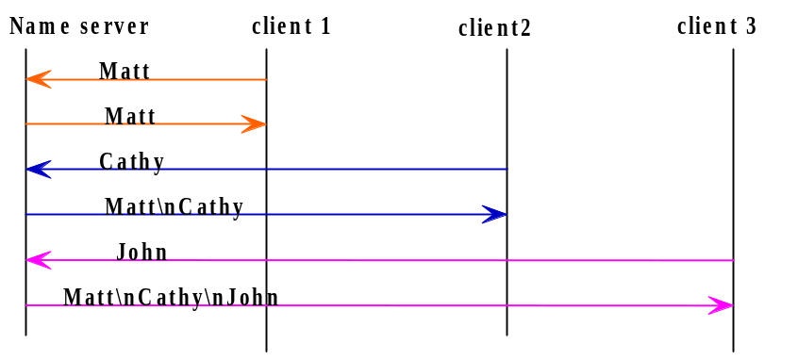
- Is this server a stateful server? If so, what kind of state information (global or session) does it maintain?
- Use any one of the following suites to implement this protocol: (1) connectionless server and client, (2) connection-oriented, iterative server and client. (hand in both source JAVA code and sample execution observation)

